**BSAI-3B**

**Lab_Task_1**

**Syed Tahir Ali 103**

**Dynamic To-Do List**

**Overview**

This is a simple Python-based To-Do List program.  
It allows the user to add, view, and remove tasks one by one. The program keeps running until the user chooses to exit.

**How It Works:**

**Adding a Task**

The user selects the option to add a task and types in the task description.  
The task is then stored inside a list.

**Viewing Tasks**

The user can view all the tasks currently saved.  
Tasks are displayed in a numbered list format, showing their order.

**Removing a Task**

The user selects the option to remove a task.  
They enter the task number from the displayed list, and that specific task gets deleted.  
If the number is invalid, the program asks the user to try again.

**Exiting the Program**

When the user chooses the exit option, the program stops running.

**Example Run:**

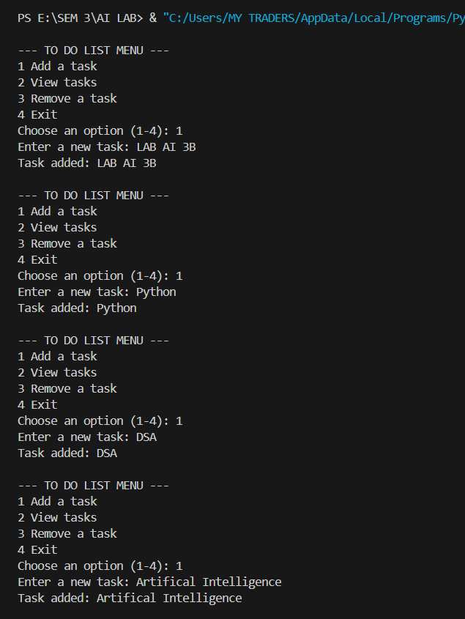

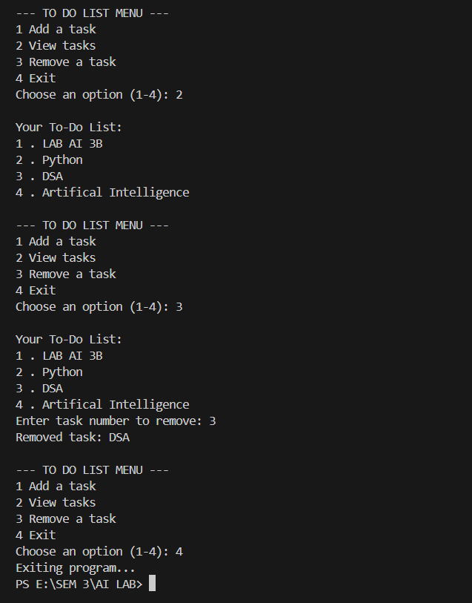

**Features**

* Add tasks dynamically
* View tasks in an organized list
* Remove tasks by number
* Simple menu-based navigation
* Runs continuously until exit is chosen